МИНИСТЕРСТВО НАУКИ И ВЫСШЕГО ОБРАЗОВАНИЯ РОССИЙСКОЙ ФЕДЕРАЦИИ

Федеральное государственное бюджетное образовательное учреждение высшего образования

«Казанский национальный исследовательский технический университет

им. А.Н. Туполева – КАИ»

Институт компьютерных технологий и защиты информации

Отделение СПО ИКТЗИ (Колледж информационных технологий)

ЛАБОРАТОРНАЯ РАБОТА №7

по дисциплине

Разработка программных модулей

Тема: «Трансформация в WPF-приложениях»

Работу выполнил

Студент гр.4335

Желваков А. С.

Принял

Преподаватель Лоповок Е.Е.

Казань 2024

Задание 1

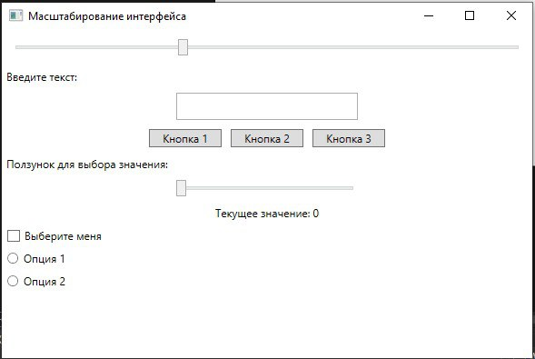

Рис. 1.1 - Начальное состояние экрана.

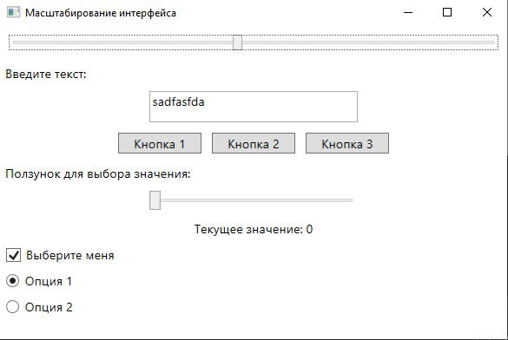

Рис. 1.2 - Изменение масштаба на больший.

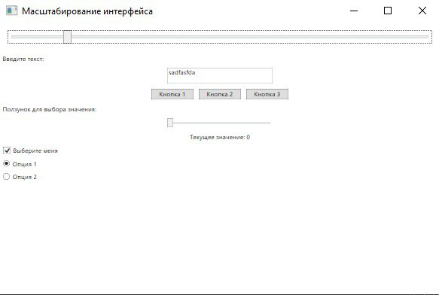

Рис. 1.3 - Изменение масштаба на меньший.

Задание 2

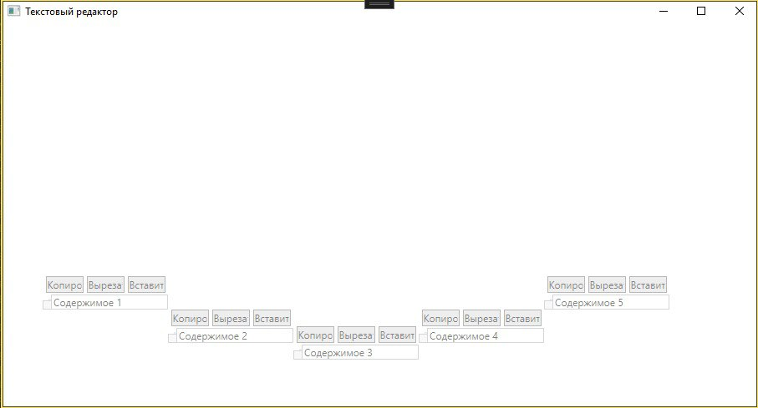Рис. 2.1 - Начальное состояние экрана.

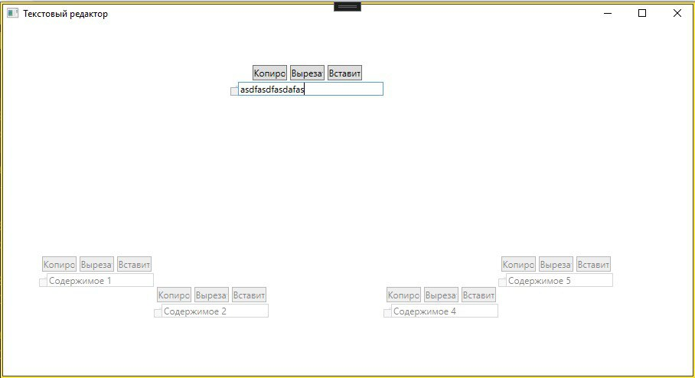Рис. 2.2 - Выбор элемента и изменение текстового блока.

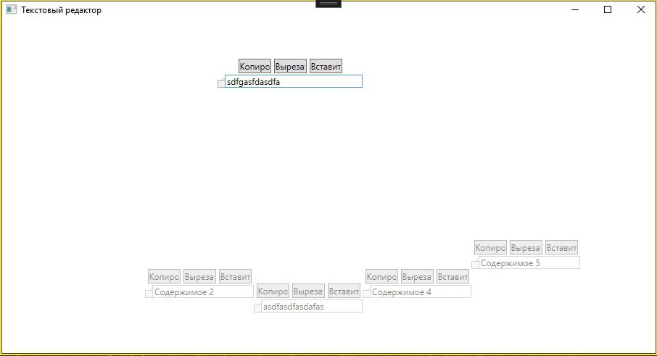Рис. 2.3 - Выбор другого элемента и изменение текстового блока.

Листинг.

Задание 1

<Window x:Class="ScalingApp.MainWindow"

xmlns="http://schemas.microsoft.com/winfx/2006/xaml/presentation"

xmlns:x="http://schemas.microsoft.com/winfx/2006/xaml"

xmlns:local="clr-namespace:ScalingApp"

Title="Масштабирование интерфейса" Height="400" Width="600">

<Window.Resources>

<local:ScaleConverter x:Key="ScaleConverter"/>

</Window.Resources>

<StackPanel>

<Slider x:Name="ScaleSlider" Minimum="0.5" Maximum="2.0" Value="1.0" TickFrequency="0.1"

IsSnapToTickEnabled="True" Margin="10" />

<StackPanel LayoutTransform="{Binding ElementName=ScaleSlider, Path=Value, Converter={StaticResource ScaleConverter}}">

<TextBlock Text="Введите текст:" Margin="5"/>

<TextBox Width="200" Height="30" Margin="5"/>

<StackPanel Orientation="Horizontal" HorizontalAlignment="Center">

<Button Content="Кнопка 1" Width="80" Margin="5"/>

<Button Content="Кнопка 2" Width="80" Margin="5"/>

<Button Content="Кнопка 3" Width="80" Margin="5"/>

</StackPanel>

<TextBlock Text="Ползунок для выбора значения:" Margin="5"/>

<Slider x:Name="ValueSlider" Width="200" Minimum="0" Maximum="100" Margin="5"/>

<TextBlock Text="{Binding ElementName=ValueSlider, Path=Value, StringFormat='Текущее значение: {0:F0}'}"

HorizontalAlignment="Center" Margin="5"/>

<CheckBox Content="Выберите меня" Margin="5"/>

<RadioButton Content="Опция 1" GroupName="Options" Margin="5"/>

<RadioButton Content="Опция 2" GroupName="Options" Margin="5"/>

</StackPanel>

</StackPanel>

</Window>

using System;

using System.Globalization;

using System.Windows.Data;

using System.Windows.Media;

namespace ScalingApp

{

public class ScaleConverter : IValueConverter

{

public object Convert(object value, Type targetType, object parameter, CultureInfo culture)

{

double scale = (double)value;

return new ScaleTransform(scale, scale);

}

public object ConvertBack(object value, Type targetType, object parameter, CultureInfo culture)

{

throw new NotImplementedException();

}

}

}

Задание 2

<Window x:Class="TextEditorApp.MainWindow"

xmlns="http://schemas.microsoft.com/winfx/2006/xaml/presentation"

xmlns:x="http://schemas.microsoft.com/winfx/2006/xaml"

Title="Текстовый редактор" Height="500" Width="800">

<Window.Resources>

<!-- Анимация для перемещения блока в центр -->

<Storyboard x:Key="MoveToCenter">

<DoubleAnimation Storyboard.TargetProperty="(Canvas.Left)" To="300" Duration="0:0:0.3"/>

<DoubleAnimation Storyboard.TargetProperty="(Canvas.Top)" To="50" Duration="0:0:0.3"/>

<DoubleAnimation Storyboard.TargetProperty="Width" To="200" Duration="0:0:0.3"/>

<DoubleAnimation Storyboard.TargetProperty="Opacity" To="1" Duration="0:0:0.3"/>

<Int32Animation Storyboard.TargetProperty="(Panel.ZIndex)" To="1" Duration="0:0:0"/>

</Storyboard>

<!-- Анимации для возврата блоков на исходное место -->

<Storyboard x:Key="MoveToOriginal1">

<DoubleAnimation Storyboard.TargetProperty="(Canvas.Left)" To="50" Duration="0:0:0.3"/>

<DoubleAnimation Storyboard.TargetProperty="(Canvas.Top)" To="300" Duration="0:0:0.3"/>

<DoubleAnimation Storyboard.TargetProperty="Width" To="150" Duration="0:0:0.3"/>

<DoubleAnimation Storyboard.TargetProperty="Opacity" To="0.5" Duration="0:0:0.3"/>

<Int32Animation Storyboard.TargetProperty="(Panel.ZIndex)" To="0" Duration="0:0:0"/>

</Storyboard>

<Storyboard x:Key="MoveToOriginal2">

<DoubleAnimation Storyboard.TargetProperty="(Canvas.Left)" To="200" Duration="0:0:0.3"/>

<DoubleAnimation Storyboard.TargetProperty="(Canvas.Top)" To="340" Duration="0:0:0.3"/>

<DoubleAnimation Storyboard.TargetProperty="Width" To="150" Duration="0:0:0.3"/>

<DoubleAnimation Storyboard.TargetProperty="Opacity" To="0.5" Duration="0:0:0.3"/>

<Int32Animation Storyboard.TargetProperty="(Panel.ZIndex)" To="0" Duration="0:0:0"/>

</Storyboard>

<Storyboard x:Key="MoveToOriginal3">

<DoubleAnimation Storyboard.TargetProperty="(Canvas.Left)" To="350" Duration="0:0:0.3"/>

<DoubleAnimation Storyboard.TargetProperty="(Canvas.Top)" To="360" Duration="0:0:0.3"/>

<DoubleAnimation Storyboard.TargetProperty="Width" To="150" Duration="0:0:0.3"/>

<DoubleAnimation Storyboard.TargetProperty="Opacity" To="0.5" Duration="0:0:0.3"/>

<Int32Animation Storyboard.TargetProperty="(Panel.ZIndex)" To="0" Duration="0:0:0"/>

</Storyboard>

<Storyboard x:Key="MoveToOriginal4">

<DoubleAnimation Storyboard.TargetProperty="(Canvas.Left)" To="500" Duration="0:0:0.3"/>

<DoubleAnimation Storyboard.TargetProperty="(Canvas.Top)" To="340" Duration="0:0:0.3"/>

<DoubleAnimation Storyboard.TargetProperty="Width" To="150" Duration="0:0:0.3"/>

<DoubleAnimation Storyboard.TargetProperty="Opacity" To="0.5" Duration="0:0:0.3"/>

<Int32Animation Storyboard.TargetProperty="(Panel.ZIndex)" To="0" Duration="0:0:0"/>

</Storyboard>

<Storyboard x:Key="MoveToOriginal5">

<DoubleAnimation Storyboard.TargetProperty="(Canvas.Left)" To="650" Duration="0:0:0.3"/>

<DoubleAnimation Storyboard.TargetProperty="(Canvas.Top)" To="300" Duration="0:0:0.3"/>

<DoubleAnimation Storyboard.TargetProperty="Width" To="150" Duration="0:0:0.3"/>

<DoubleAnimation Storyboard.TargetProperty="Opacity" To="0.5" Duration="0:0:0.3"/>

<Int32Animation Storyboard.TargetProperty="(Panel.ZIndex)" To="0" Duration="0:0:0"/>

</Storyboard>

</Window.Resources>

<Canvas Background="White" Width="1200" Height="800">

<!-- Первый блок -->

<StackPanel Width="150" Height="150" Canvas.Left="50" Canvas.Top="300" Opacity="0.5" Focusable="True">

<StackPanel Orientation="Horizontal" HorizontalAlignment="Center">

<Button Content="Копировать" Width="45" Margin="2"/>

<Button Content="Вырезать" Width="45" Margin="2"/>

<Button Content="Вставить" Width="45" Margin="2"/>

</StackPanel>

<DockPanel>

<Slider Orientation="Vertical" Minimum="0" Maximum="100" Width="10" DockPanel.Dock="Left"/>

<TextBox Text="Содержимое 1" VerticalScrollBarVisibility="Auto" AcceptsReturn="True"/>

</DockPanel>

<StackPanel.Triggers>

<EventTrigger RoutedEvent="GotFocus">

<BeginStoryboard Storyboard="{StaticResource MoveToCenter}"/>

</EventTrigger>

<EventTrigger RoutedEvent="LostFocus">

<BeginStoryboard Storyboard="{StaticResource MoveToOriginal1}"/>

</EventTrigger>

</StackPanel.Triggers>

</StackPanel>

<!-- Второй блок -->

<StackPanel Width="150" Height="150" Canvas.Left="200" Canvas.Top="340" Opacity="0.5" Focusable="True">

<StackPanel Orientation="Horizontal" HorizontalAlignment="Center">

<Button Content="Копировать" Width="45" Margin="2"/>

<Button Content="Вырезать" Width="45" Margin="2"/>

<Button Content="Вставить" Width="45" Margin="2"/>

</StackPanel>

<DockPanel>

<Slider Orientation="Vertical" Minimum="0" Maximum="100" Width="10" DockPanel.Dock="Left"/>

<TextBox Text="Содержимое 2" VerticalScrollBarVisibility="Auto" AcceptsReturn="True"/>

</DockPanel>

<StackPanel.Triggers>

<EventTrigger RoutedEvent="GotFocus">

<BeginStoryboard Storyboard="{StaticResource MoveToCenter}"/>

</EventTrigger>

<EventTrigger RoutedEvent="LostFocus">

<BeginStoryboard Storyboard="{StaticResource MoveToOriginal2}"/>

</EventTrigger>

</StackPanel.Triggers>

</StackPanel>

<!-- Третий блок -->

<StackPanel Width="150" Height="150" Canvas.Left="350" Canvas.Top="360" Opacity="0.5" Focusable="True">

<StackPanel Orientation="Horizontal" HorizontalAlignment="Center">

<Button Content="Копировать" Width="45" Margin="2"/>

<Button Content="Вырезать" Width="45" Margin="2"/>

<Button Content="Вставить" Width="45" Margin="2"/>

</StackPanel>

<DockPanel>

<Slider Orientation="Vertical" Minimum="0" Maximum="100" Width="10" DockPanel.Dock="Left"/>

<TextBox Text="Содержимое 3" VerticalScrollBarVisibility="Auto" AcceptsReturn="True"/>

</DockPanel>

<StackPanel.Triggers>

<EventTrigger RoutedEvent="GotFocus">

<BeginStoryboard Storyboard="{StaticResource MoveToCenter}"/>

</EventTrigger>

<EventTrigger RoutedEvent="LostFocus">

<BeginStoryboard Storyboard="{StaticResource MoveToOriginal3}"/>

</EventTrigger>

</StackPanel.Triggers>

</StackPanel>

<!-- Четвертый блок -->

<StackPanel Width="150" Height="150" Canvas.Left="500" Canvas.Top="340" Opacity="0.5" Focusable="True">

<StackPanel Orientation="Horizontal" HorizontalAlignment="Center">

<Button Content="Копировать" Width="45" Margin="2"/>

<Button Content="Вырезать" Width="45" Margin="2"/>

<Button Content="Вставить" Width="45" Margin="2"/>

</StackPanel>

<DockPanel>

<Slider Orientation="Vertical" Minimum="0" Maximum="100" Width="10" DockPanel.Dock="Left"/>

<TextBox Text="Содержимое 4" VerticalScrollBarVisibility="Auto" AcceptsReturn="True"/>

</DockPanel>

<StackPanel.Triggers>

<EventTrigger RoutedEvent="GotFocus">

<BeginStoryboard Storyboard="{StaticResource MoveToCenter}"/>

</EventTrigger>

<EventTrigger RoutedEvent="LostFocus">

<BeginStoryboard Storyboard="{StaticResource MoveToOriginal4}"/>

</EventTrigger>

</StackPanel.Triggers>

</StackPanel>

<!-- Пятый блок -->

<StackPanel Width="150" Height="150" Canvas.Left="650" Canvas.Top="300" Opacity="0.5" Focusable="True">

<StackPanel Orientation="Horizontal" HorizontalAlignment="Center">

<Button Content="Копировать" Width="45" Margin="2"/>

<Button Content="Вырезать" Width="45" Margin="2"/>

<Button Content="Вставить" Width="45" Margin="2"/>

</StackPanel>

<DockPanel>

<Slider Orientation="Vertical" Minimum="0" Maximum="100" Width="10" DockPanel.Dock="Left"/>

<TextBox Text="Содержимое 5" VerticalScrollBarVisibility="Auto" AcceptsReturn="True"/>

</DockPanel>

<StackPanel.Triggers>

<EventTrigger RoutedEvent="GotFocus">

<BeginStoryboard Storyboard="{StaticResource MoveToCenter}"/>

</EventTrigger>

<EventTrigger RoutedEvent="LostFocus">

<BeginStoryboard Storyboard="{StaticResource MoveToOriginal5}"/>

</EventTrigger>

</StackPanel.Triggers>

</StackPanel>

</Canvas>

</Window>